GEORGE.W.BUSH RECOUNTED (CASE FOR RECTIFICATION)

Boris Izraitel

Here, In Russia, where, civil services are not obsessed, to put it mildly, with accuracy in record keeping, casting doubt on every reported birth time is an absolutely justifiable habit. Though this may seem odd to western astrologers, I believe that in the long run such a habit will be far more productive than taking the birth certificate's information for granted.
I hope you will agree that the uncritical adoption of reported "true" birth times is not good practice for astrologers, and has nothing to do with a scientific approach to astrology. The fact that a time has been recorded is no guarantee of its accuracy.
Below, I attempt to present a set of arguments in favor of a new version of President Bush's chart (fig.2), but first let me point out the discrepancies between the astrological symbolism in an accepted GWB chart (fig.1) and reality as I see it.
1) The Presidency and the 10th house
Looking at the accepted version of Bush's chart, I can't help but ask the following question: How is it that the world's most powerful politician has such an undistinguished 10th house?
I wonder if anyone (staying within the classical framework) can find at least one dignity relating to the social/professional position of the horoscope in question.
What we see in this chart is a whole bunch of impairments. Mars, the 10th house ruler, is in detriment by house as well as by sign position. Saturn, the natural ruler of the 10th house, is totally conquered, and the Sun and Jupiter are far from being able to stand for any significant career ambitions.
The only dignified planet is rising Pluto. However, millions of the same generation share this Pluto position. The question is why did the world's most powerful office go to the representative of this generation with the weakest 10th house?

One may say :" He is just a puppet!"
With all Eastern planets that's absolutely impossible.
The old version pictured a man with hidden ambitions having no real public outlet.
2) Father image and Sun position.
It so happened that I came across the GWB horoscope while engaged in an extensive astrological study on child-parent relationships. The Bush dynasty appeared to me as a unique opportunity to apply my findings on a broader scale.
However, the GWB natal chart with 12th house Sun and Saturn fails to meet any conformity achieved in my research. I have registered numerous cases where Sun/Saturn double water placement (meaning sign and house both belong to water element) resulted in an unknown father, a father kept in jail or a hospital, or the father died before the person's birth. At the very least, the father may simply be inaccessible by virtue of some sort of addiction (alcohol and drugs being a common factor). These problems may only be aggravated when both planets have stressful aspects from another significator of parental figures such as Moon or Jupiter. Such constellations, as I found, once and again manifest themselves in dysfunctional fathers, who don't deserve social respect.

Now I'd like to suggest a possible solution to these apparent incongruities by introducing a new version of GWB's natal chart ( fig.2). This chart appears to give reasonable explanations for Bush's characteristic features, and the symbolism of this chart looks much more convincing.
1) Taurus MC
History
Many authors have pointed out that the Taurus/Scorpio axis is an important archetype in US history. This axis is accented in the horoscopes of all US Presidents (the only exception so far is Dwight Eisenhower, given that his chart is properly rectified).
Synastry.
The axis is prominent in the charts of Laura Bush and Dick Cheney.
Name.
Obviously, a person's name is one of the most important components of their individuality. As such, it must be imprinted in one's chart. Usually ASC, MC and the luminaries exhibit the strongest correlation with a name of a person. My observations show a significant connection between the name "George" and the earth element ("Geo" is Greek for Earth). By the way, this connection can be easily found in US presidential history.
Two other US Presidents with the first name of George, Washington and GWB's father, have prominent earth elements: rising Taurus - Washington, rising Virgo - Bush. If it's true that Venus rules plants, then it well may be that bushes refer to the realm of Taurus.
2) Uranus in the 10th house
Uranus conjunct Node is a powerful focal point of the chart. This conjunction invites to the 10th house the positive influence of Libra stellium (Moon /Jupiter/Chiron). In this case, the strongest aspect of the chart, the Uranus/Jupiter trine, works to the benefit of the 10th house (social advancement). What Bush himself refered to as his "nomadic years"- the period of social "uncertainty" - is a typical sign of the higher planet's influence on the 10th house. Bush's service as a pilot in the Air National Guard is a clear indication of a link between Uranus and the 10th house.
3) The Sun and Saturn in 11th house
Father - son relationship
I think it's very unlikely that GWB is ashamed of his father. In fact, he has many reasons to be proud of his dad who was himself President. University friends recall that Bush described his father in "almost God-like" terms. Indeed, the Sun in the 11th has to do with idealization of the father.
Of course, there should be a 12th house overtone as far as GWB's father-sun relationship is concerned. Father Bush was cut off from his progeny by ambition, responsibility, and duty. Moreover, he was the head of the Central Intelligence Agency, a highly secretive position that further distanced him from his children. This is a very good example described by the positioning of the 10th and 4th house rulers in the 12th.
Father image
Apart from reflecting the particular mode of the father-son relationship, the positioning of Sun and Saturn in the son's horoscope indicate a general psychological make-up of the father - specifically, his character and individual qualities. The most prominent features of Bush Sr.'s chart are a strong air element, and an exact Sun-Uranus square (Sun and Uranus both positioned exactly on the angles). Thus, we have a synthesis of the 11th house, which is an air house ruled by Uranus.
It's worth noting that Bush's younger brother, Jeb, has an Aquarian Sun.
Children
The 11th house Saturn often signifies the delay with children. Bush's twins were born when their father was 35.
Friendship and group activities

A person with the Sun/Saturn conjunction in the 11th is inclined to dominate in friendships, and control the group that shares the same aspirations.

Childhood pals recall that Bush was "always leading his gang on adventures", "... after school we'd pick teams and play... Bush jumped out to be captain." Upon an enrolling at a new school, George made an easy transition; he was quickly elected as a class officer and made the high school football team. As a student, he was known as a campus mover.
This hardly would be the case with a 12th house person.
We have no evidence that Bush likes to spend time alone, immersed in either introspection, sorrow, a day dream, or even a good book - things that would be typical of a 12th house Sun/Saturn conjunction. On the contrary, biographers describe him as "a man who loves crowds, especially when he is the center of attention, making people laugh."
4) Mars in the 1st house
He is viewed mostly as a straight shooter, and known for his blunt outspokenness - "you know where you stand with him". This is an extremely strange characteristic for a person with Mercury rising and both luminaries in the mutable houses, but fits absolutely a Mars rising person. People who meet Bush first and most of all refer to his energy, quick temper, aggressiveness, and his ability to act fast. Bush advisers know that he is "action-oriented, not one to agonize over 30-page memos. He wants the one-page executive summary and a decision. Cut to the chase."

That is all as far as main points of qualitative rectification are concerned.
What about events?
I believe that events ( in terms of quantity, not quality) are crucial when one is to confirm the exact cusps' coordinates after planets' distribution in natal houses have been absolutely verified.
I have big doubts if they are of a great value in other cases.
The point is that probability of coincidence of event and aspect is much higher than one may expect.
Particularly in the typical traditional case where number of sensitive points equal to 13,
Average proportion of points rejected on symbolic grounds is 0.5,
Number of aspects is 16 and the maximum orb is 22 minutes,
19 out of 20 events will fit purely by chance.

Nevertheless, I'd like to give a comparative picture concerning one of the turning points of GWB life.
He quit drinking and was inspired to read Bible in July 1986
New version : Directed ASC conjunct natal Neptune ( progressed Moon ingressed 8th house)
Old version: no major aspects.

My deep conviction is that when a rectified chart is presented in a reasonable way, and the astrologer strictly follows fundamental principles of rectification, this chart has at least the same chances to be accepted by the astrological community as one based upon a carefully recorded time. Naturally, charts rectified without referring to a certificate or another data source must evoke some suspicion, but it's nevertheless unfair to treat any rectified chart as unreliable, no matter how reasonable the justification sounds.

Figure 1 : July 6,1946, 7:26 am EDT, New Haven 72w55 41n18

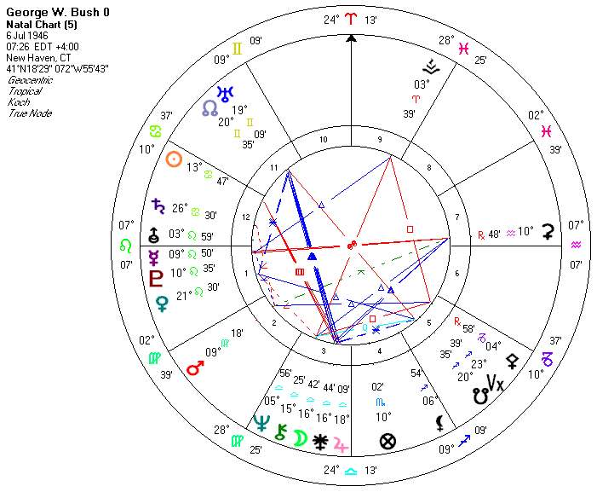

Figure 2 : July 6,1946, 9.04 am EDT, New Haven 72w55 41n18

